[Organisation] · PHASE C
Application Use Cases
Twenty-three use cases across eleven roles, and the eight that belong to a role nobody performs
Field | Detail
Version | 0.1 — Draft
Date | September 2027
Owner | Application Domain Architect, with the Business Domain Architect
Approver | Architecture Board
Source | Actors from metamodel O10, roles from O11, processes from O16. The chain is composed from relations R08, R09, R14 and R20. Applications from O23.
Classification | Internal

1. How a use case is composed
A use case here is a role performing a business process, with the applications that support it. The actors and roles are the existing catalogue entries; nothing is invented for this artifact.

Link | What it is | Source | What it shows here
Actor | A person or organisation that exists. | O10 Actor, 20 records | Ten are external: brokers, the bancassurance partner, loss adjusters, funeral parlours.
performs Role | A role is a set of responsibilities, not a person. Several actors can perform one role. | R08, 16 relationships | Eight roles have no actor performing them. That is where this artifact starts to bite.
participates in Process | The role does something in a modelled business process. | R09, 23 relationships | Eleven of twenty-seven roles participate in a process. These twenty-three pairings are the use cases.
Process orchestrates Service | The process calls on one or more business services. | R14, 24 relationships | Three processes orchestrate no service, which is why three use cases have no application behind them.
Application implements Service | An application delivers the service, wholly or partly. | R20, 35 relationships | Sixteen of the thirty-five are Partial: the service runs for part of the book only.

Eight of twenty-three use cases belong to a role no actor performs
The process is modelled, the applications are in place, and nobody is recorded as doing the work. Disbursing a payment, handling a complaint and producing a prudential return all sit here.

2. What the artifact is for
Use | How | Here
Impact assessment | Before changing an application, read up the column to the roles that depend on it. | PolicyHub-ST appears in six use cases across four roles.
Access design | A use case is the unit access should be granted against, not the application. | The data security view found that Restricted data is reached by role rather than by named individual. This is the layer where that would be fixed.
Staffing gaps | A use case with no actor is work the organisation believes is happening. | Eight of twenty-three. Six are in collections and compliance.
Requirements | A use case with no application is a requirement that has not been written down. | Three of twenty-three, and one of them creates the party record the whole identity problem starts from.

3. The use case diagram
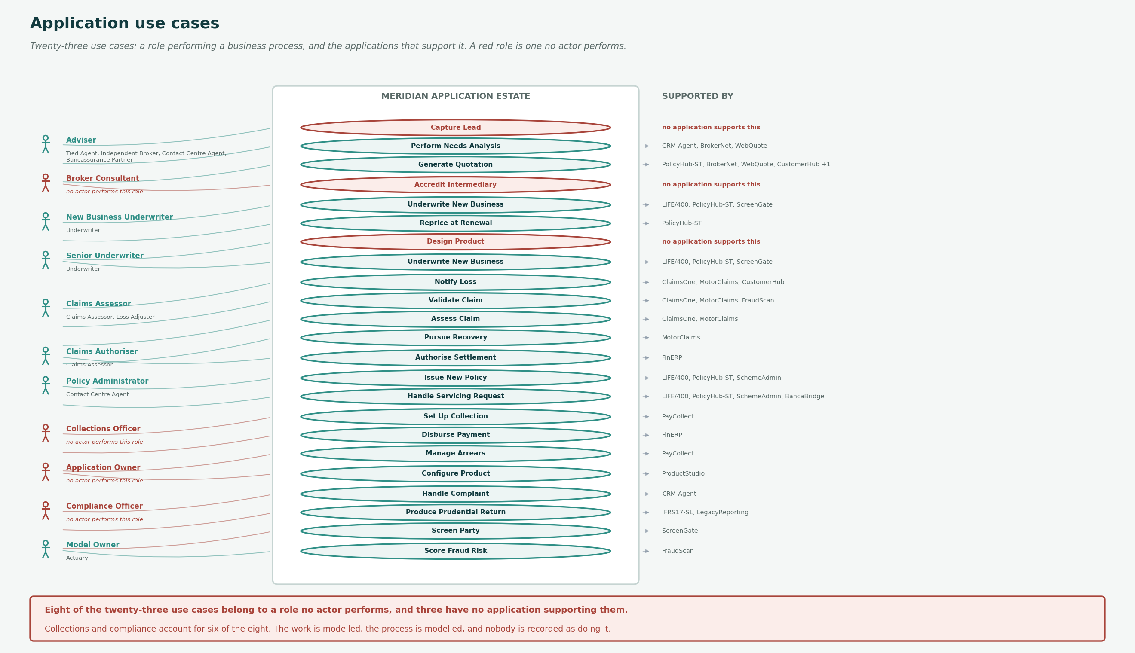
Twenty-three use cases. A red role is one no actor performs; a red use case has no application supporting it.

4. Use case register
Ref | Role | Part | Use case | Actors performing the role | Applications
UC-01 | Adviser | Acco | Capture Lead | Tied Agent, Independent Broker, Contact Centre Agent, Bancassurance Partner | none — no application supports this
UC-02 | Adviser | Acco | Perform Needs Analysis | Tied Agent, Independent Broker, Contact Centre Agent, Bancassurance Partner | CRM-Agent, BrokerNet, WebQuote
UC-03 | Adviser | Resp | Generate Quotation | Tied Agent, Independent Broker, Contact Centre Agent, Bancassurance Partner | PolicyHub-ST, BrokerNet, WebQuote, CustomerHub, AgentMobile
UC-04 | Broker Consultant | Acco | Accredit Intermediary | none — no actor performs this role | none — no application supports this
UC-05 | New Business Underwriter | Acco | Underwrite New Business | Underwriter | LIFE/400, PolicyHub-ST, ScreenGate
UC-06 | New Business Underwriter | Acco | Reprice at Renewal | Underwriter | PolicyHub-ST
UC-07 | New Business Underwriter | Acco | Design Product | Underwriter | none — no application supports this
UC-08 | Senior Underwriter | Cons | Underwrite New Business | Underwriter | LIFE/400, PolicyHub-ST, ScreenGate
UC-09 | Claims Assessor | Resp | Notify Loss | Claims Assessor, Loss Adjuster | ClaimsOne, MotorClaims, CustomerHub
UC-10 | Claims Assessor | Acco | Validate Claim | Claims Assessor, Loss Adjuster | ClaimsOne, MotorClaims, FraudScan
UC-11 | Claims Assessor | Acco | Assess Claim | Claims Assessor, Loss Adjuster | ClaimsOne, MotorClaims
UC-12 | Claims Assessor | Resp | Pursue Recovery | Claims Assessor, Loss Adjuster | MotorClaims
UC-13 | Claims Authoriser | Acco | Authorise Settlement | Claims Assessor | FinERP
UC-14 | Policy Administrator | Acco | Issue New Policy | Contact Centre Agent | LIFE/400, PolicyHub-ST, SchemeAdmin
UC-15 | Policy Administrator | Acco | Handle Servicing Request | Contact Centre Agent | LIFE/400, PolicyHub-ST, SchemeAdmin, BancaBridge
UC-16 | Collections Officer | Acco | Set Up Collection | none — no actor performs this role | PayCollect
UC-17 | Collections Officer | Resp | Disburse Payment | none — no actor performs this role | FinERP
UC-18 | Collections Officer | Acco | Manage Arrears | none — no actor performs this role | PayCollect
UC-19 | Application Owner | Acco | Configure Product | none — no actor performs this role | ProductStudio
UC-20 | Compliance Officer | Acco | Handle Complaint | none — no actor performs this role | CRM-Agent
UC-21 | Compliance Officer | Acco | Produce Prudential Return | none — no actor performs this role | IFRS17-SL, LegacyReporting
UC-22 | Compliance Officer | Resp | Screen Party | none — no actor performs this role | ScreenGate
UC-23 | Model Owner | Acco | Score Fraud Risk | Actuary | FraudScan

5. Use case detail
Each use case with what happens, the business services it orchestrates and the data it touches.

UC-01 Capture Lead
Adviser (accountable) · no application supports this
Record a prospect and qualify the need.
Actors | Tied Agent, Independent Broker (external), Contact Centre Agent, Bancassurance Partner (external)
Business services | none — the process orchestrates no service
Applications | none
Data touched | Party [CR], Contact Detail [CR]

UC-02 Perform Needs Analysis
Adviser (accountable)
Establish need and produce an advice record under FAIS.
Actors | Tied Agent, Independent Broker (external), Contact Centre Agent, Bancassurance Partner (external)
Business services | Capture Application
Applications | CRM-Agent (partial), BrokerNet (partial), WebQuote (partial)
Data touched | Advice Record [C], Customer [RU]

UC-03 Generate Quotation
Adviser (responsible)
Rate a risk and produce a binding quote.
Actors | Tied Agent, Independent Broker (external), Contact Centre Agent, Bancassurance Partner (external)
Business services | Produce Quotation, Resolve Customer Identity
Applications | PolicyHub-ST (partial), BrokerNet (partial), WebQuote (partial), CustomerHub (full), AgentMobile (partial)
Data touched | Product Definition [R], Risk Object [CR], Party [R]

UC-04 Accredit Intermediary
Broker Consultant (accountable) · no actor performs this role · no application supports this
Verify, contract and onboard a broker or partner.
Actors | none
Business services | none — the process orchestrates no service
Applications | none
Data touched | Intermediary [CRU]

UC-05 Underwrite New Business
New Business Underwriter (accountable)
Assess risk, apply loadings or exclusions, decide.
Actors | Underwriter
Business services | Underwrite Risk, Screen Party
Applications | LIFE/400 (partial), PolicyHub-ST (partial), ScreenGate (full)
Data touched | Underwriting Decision [C], Risk Object [RU], Life Assured [CR]

UC-06 Reprice at Renewal
New Business Underwriter (accountable)
Recalculate premium and issue renewal terms.
Actors | Underwriter
Business services | Renew Policy
Applications | PolicyHub-ST (full)
Data touched | Policy [RU], Product Definition [R], Underwriting Decision [CR]

UC-07 Design Product
New Business Underwriter (accountable) · no application supports this
Define cover, rating, rules and wordings.
Actors | Underwriter
Business services | none — the process orchestrates no service
Applications | none
Data touched | Product Definition [C]

UC-08 Underwrite New Business
Senior Underwriter (consulted)
Assess risk, apply loadings or exclusions, decide.
Actors | Underwriter
Business services | Underwrite Risk, Screen Party
Applications | LIFE/400 (partial), PolicyHub-ST (partial), ScreenGate (full)
Data touched | Underwriting Decision [C], Risk Object [RU], Life Assured [CR]

UC-09 Notify Loss
Claims Assessor (responsible)
Capture first notification of loss and evidence.
Actors | Claims Assessor, Loss Adjuster (external)
Business services | Notify Claim, Resolve Customer Identity
Applications | ClaimsOne (partial), MotorClaims (full), CustomerHub (full)
Data touched | Claim [C], Document [C], Party [R]

UC-10 Validate Claim
Claims Assessor (accountable)
Confirm cover, currency of premium and eligibility.
Actors | Claims Assessor, Loss Adjuster (external)
Business services | Assess Claim, Detect Fraud
Applications | ClaimsOne (full), MotorClaims (full), FraudScan (full)
Data touched | Claim [RU], Policy [R], Premium Transaction [R]

UC-11 Assess Claim
Claims Assessor (accountable)
Adjudicate against policy terms and evidence.
Actors | Claims Assessor, Loss Adjuster (external)
Business services | Assess Claim
Applications | ClaimsOne (full), MotorClaims (full)
Data touched | Claim [RU], Policy Benefit [R]

UC-12 Pursue Recovery
Claims Assessor (responsible)
Recover from third parties and salvage.
Actors | Claims Assessor, Loss Adjuster (external)
Business services | Recover Claim
Applications | MotorClaims (full)
Data touched | Claim [U], Reinsurance Cession [RU]

UC-13 Authorise Settlement
Claims Authoriser (accountable)
Approve payment within or above mandate.
Actors | Claims Assessor
Business services | Settle Claim
Applications | FinERP (full)
Data touched | Claim [U], Claim Payment [C]

UC-14 Issue New Policy
Policy Administrator (accountable)
Create the policy record and produce documents.
Actors | Contact Centre Agent
Business services | Issue Policy
Applications | LIFE/400 (full), PolicyHub-ST (full), SchemeAdmin (full)
Data touched | Policy [C], Policy Benefit [C], Document [C], Beneficiary [CR]

UC-15 Handle Servicing Request
Policy Administrator (accountable)
Process a customer alteration or enquiry.
Actors | Contact Centre Agent
Business services | Amend Policy, Maintain Customer Record
Applications | LIFE/400 (full/partial), PolicyHub-ST (full/partial), SchemeAdmin (partial), BancaBridge (partial)
Data touched | Policy [RU], Contact Detail [RU], Document [C]

UC-16 Set Up Collection
Collections Officer (accountable) · no actor performs this role
Establish the collection mandate and first debit.
Actors | none
Business services | Collect Premium
Applications | PayCollect (full)
Data touched | Premium Transaction [C]

UC-17 Disburse Payment
Collections Officer (responsible) · no actor performs this role
Pay the claimant and confirm.
Actors | none
Business services | Settle Claim
Applications | FinERP (full)
Data touched | Claim Payment [U], Financial Transaction [C]

UC-18 Manage Arrears
Collections Officer (accountable) · no actor performs this role
Retry collection, contact customer, prevent lapse.
Actors | none
Business services | Manage Arrears
Applications | PayCollect (full)
Data touched | Premium Transaction [RU], Policy [RU]

UC-19 Configure Product
Application Owner (accountable) · no actor performs this role
Implement the product definition in the platform.
Actors | none
Business services | Configure Product
Applications | ProductStudio (full)
Data touched | Product Definition [CRU]

UC-20 Handle Complaint
Compliance Officer (accountable) · no actor performs this role
Log, investigate, resolve and feed back root cause.
Actors | none
Business services | Handle Complaint
Applications | CRM-Agent (full)
Data touched | Complaint [CRU], Customer [R]

UC-21 Produce Prudential Return
Compliance Officer (accountable) · no actor performs this role
Assemble, reconcile and submit a prudential return.
Actors | none
Business services | Produce Regulatory Return
Applications | IFRS17-SL (partial), LegacyReporting (partial)
Data touched | Regulatory Return [C], Financial Transaction [R], Policy [R]

UC-22 Screen Party
Compliance Officer (responsible) · no actor performs this role
Sanctions, PEP and due diligence screening.
Actors | none
Business services | Screen Party
Applications | ScreenGate (full)
Data touched | Party [R], Customer [RU]

UC-23 Score Fraud Risk
Model Owner (accountable)
Score an application or claim for fraud indicators.
Actors | Actuary
Business services | Detect Fraud
Applications | FraudScan (full)
Data touched | Claim [R], Model [R]

6. Role coverage
All twenty-seven roles. Sixteen appear in no use case because they participate in no modelled business process.

Ref | Role | Actors performing it | Use cases
ROL-01 | Adviser | Tied Agent, Independent Broker, Contact Centre Agent, Bancassurance Partner | UC-01, UC-02, UC-03
ROL-02 | Broker Consultant | none | UC-04
ROL-03 | New Business Underwriter | Underwriter | UC-05, UC-06, UC-07
ROL-04 | Senior Underwriter | Underwriter | UC-08
ROL-05 | Claims Assessor | Claims Assessor, Loss Adjuster | UC-09, UC-10, UC-11, UC-12
ROL-06 | Claims Authoriser | Claims Assessor | UC-13
ROL-07 | Policy Administrator | Contact Centre Agent | UC-14, UC-15
ROL-08 | Collections Officer | none | UC-16, UC-17, UC-18
ROL-09 | Data Owner | none | no use case — participates in no modelled process
ROL-10 | Data Steward | none | no use case — participates in no modelled process
ROL-11 | Application Owner | none | UC-19
ROL-12 | Solution Architect | Enterprise Architect | no use case — participates in no modelled process
ROL-13 | Domain Architect | Enterprise Architect | no use case — participates in no modelled process
ROL-14 | Architecture Board Member | Enterprise Architect | no use case — participates in no modelled process
ROL-15 | Compliance Officer | none | UC-20, UC-21, UC-22
ROL-16 | Information Officer | none | no use case — participates in no modelled process
ROL-17 | Model Owner | Actuary | UC-23
ROL-18 | Scheme Administrator | Employer Scheme Sponsor, Fund Trustee | no use case — participates in no modelled process
ROL-19 | Claims Administrator | none | no use case — participates in no modelled process
ROL-20 | New Business Administrator | none | no use case — participates in no modelled process
ROL-21 | Renewals Administrator | none | no use case — participates in no modelled process
ROL-22 | Recoveries Officer | none | no use case — participates in no modelled process
ROL-23 | Pricing Actuary | none | no use case — participates in no modelled process
ROL-24 | Product Manager | none | no use case — participates in no modelled process
ROL-25 | Product Configuration Specialist | none | no use case — participates in no modelled process
ROL-26 | Distribution Enablement Officer | none | no use case — participates in no modelled process
ROL-27 | Finance Operations Officer | none | no use case — participates in no modelled process

7. Findings
Eight of twenty-three use cases belong to a role no actor performs
Collections Officer accounts for three, Compliance Officer for three, with Broker Consultant and Application Owner one each.
The process is modelled, the applications are in place, and nobody is recorded as doing the work. Disbursing a payment, handling a complaint and producing a prudential return all sit here. This is the same finding the Actor and Role Catalogue made at Phase B, now with the applications attached to it.
Three use cases have no application supporting them
Capture Lead, Accredit Intermediary and Design Product.
Each orchestrates no business service, so nothing implements it. Capture Lead is the first step of the acquisition value stream and the point at which a party record is created in whichever channel master the adviser happens to be using.
Compliance carries three unstaffed use cases and all three are regulatory
Handle Complaint, Produce Prudential Return and Screen Party.
Complaint handling is a COFI obligation, the prudential return is a Prudential Authority submission, and party screening is FICA. The role exists in the catalogue, the processes are modelled, and no actor performs any of them.
Seven use cases are performed by an external actor
The Adviser role is performed by independent brokers and the bancassurance partner; Claims Assessor by loss adjusters.
An external party executing a use case inside the estate is normal in insurance and worth seeing explicitly. Advice capture and claims assessment are both done by people [Organisation] does not employ, on systems [Organisation] does not fully control.
Sixteen of twenty-seven roles appear in no use case at all
They participate in no modelled business process.
Nine of those sixteen were added under CR-021 because the value streams named work nobody was accountable for. They are in the catalogue and not yet in the process model, which is the next thing to close.

Referenced artifacts
- Actor and Role Catalogue · Business Service and Function Catalog · Application Portfolio Catalogue
- Application Component Mapping · Data Security
- Metamodel O10 Actor, O11 Role, O16 Business Process, O23 Application Component; relations R08, R09, R14, R17 and R20

